Pocket Planet/Poly-planet: Planetary composition design document



Asteroids:

Asteroids are the building blocks of the game and will be utilised by players. Players goals are easy, they must compile enough asteroids in order initiate the birth of a planet, the player means is to fling incoming asteroids at the planetoid (large spherical asteroid) and in turn build enough mass to build their planets.

The asteroids featured in the game will consist of varying shapes and sizes as well as consisting of varying compositions of the minerals listed below:

Figure

* Carbon
* Ice
* Water
* Iron
* Nickel
* Metal

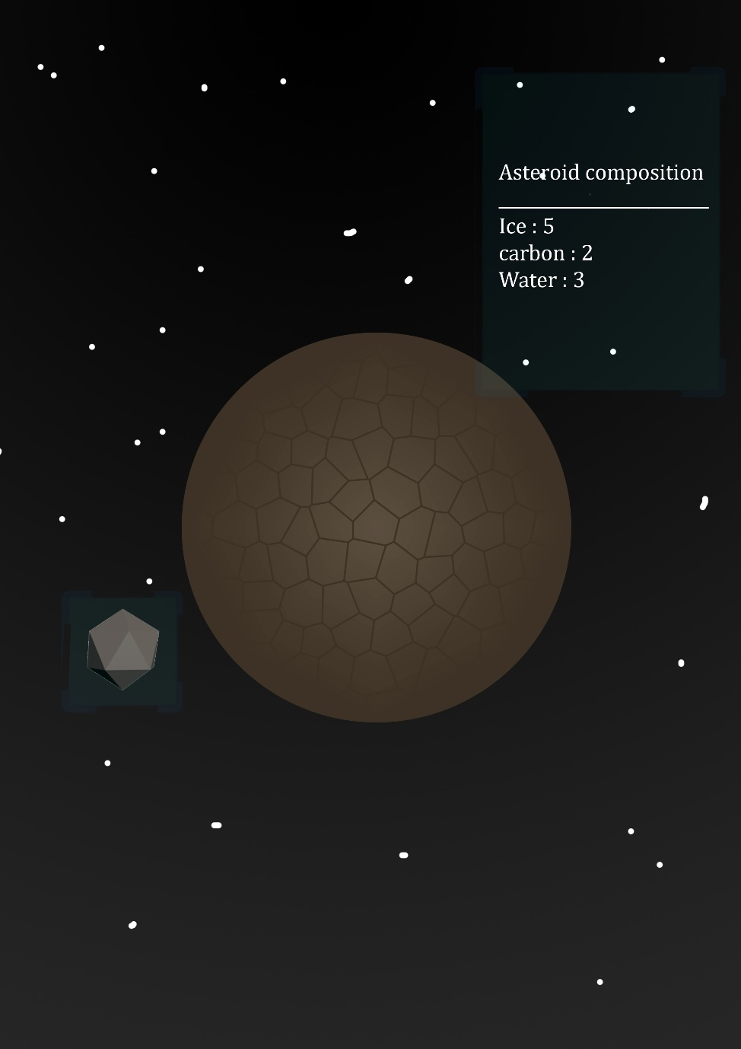The composition of asteroids can be a varied numeric mixture of two or even more of the minerals listed above. The numeric mineral value of asteroids will in turn dictate the variant of the planet the player creates. Upon tapping (pre-fling) on the asteroids a window will appear detailing the numeric value, see figure 2 for example.

Figure

Planetoids:

Additionally, planetoids are larger spherical asteroids these will be used as the core/basis of the players planet. As planetoids are blank canvases their numeric material values are set to zero. It will be the goal of the players to fling asteroids into the planetoids and subsequently build the material composition of the planets as well the planet appearance (see figure 4)

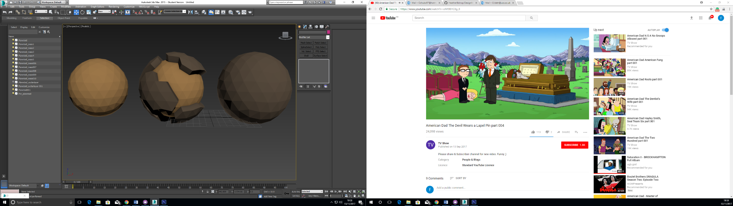

Completed Planetoid

Planetoid post asteroid collision

Core Planetoid

Figure

Composition possibilities:

|  |  |  |  |  |  |  |
| --- | --- | --- | --- | --- | --- | --- |
|  | Carbon | Ice | Water | Iron | Nickel | Gold |
| Carbon | Rocky planet | Winter Planet | Earth/ Terra based Planet | Industrial planet | Fluid metallic planet | Gold Earth like Industrial planet |
| Ice | Antarctic like planet | Ice Planet | Antarctic like planet | Industrial icey planet | Industrial Icy planet | Crystal planet |
| Water | Earth/Terra based planet | Antarctic like planet | Water planet | Metallic earth like planet | Metallic Earth like planet | Earth like Gold planet |
| Iron | Industrial planet | Industrial icy winter planet | Metallic earth like planet | Metallic iron planet | Metallic planet | Metallic Gold planet |
| Nickel | Industrial planet | Industrial winter planet | Metallic Earth like planet | Metallic nickel planet | Metallic Nickel planet | Metallic Gold planet |
| Gold | Metallic Gold planet | Crystal planet | Earth like Gold planet | Metallic Gold planet | Metallic  Gold planet | Gold planet |

Figure